**Day 3 - Assignments**

**Project 1 -**

**Deploying a Web Server in Windows Instance(Virtual Machine).**

**Step 1 - Selecting and Creating the appropriate EC2 Instance for Windows from the list.**

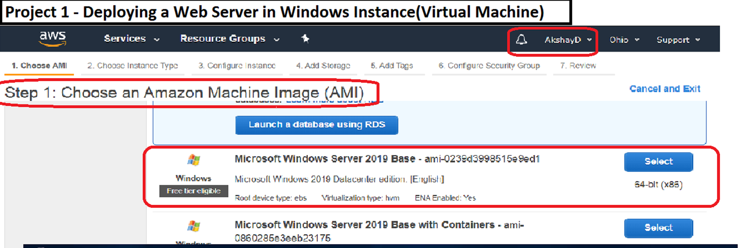

**Step 2 - Making the Windows Instance go Live using RDP.**

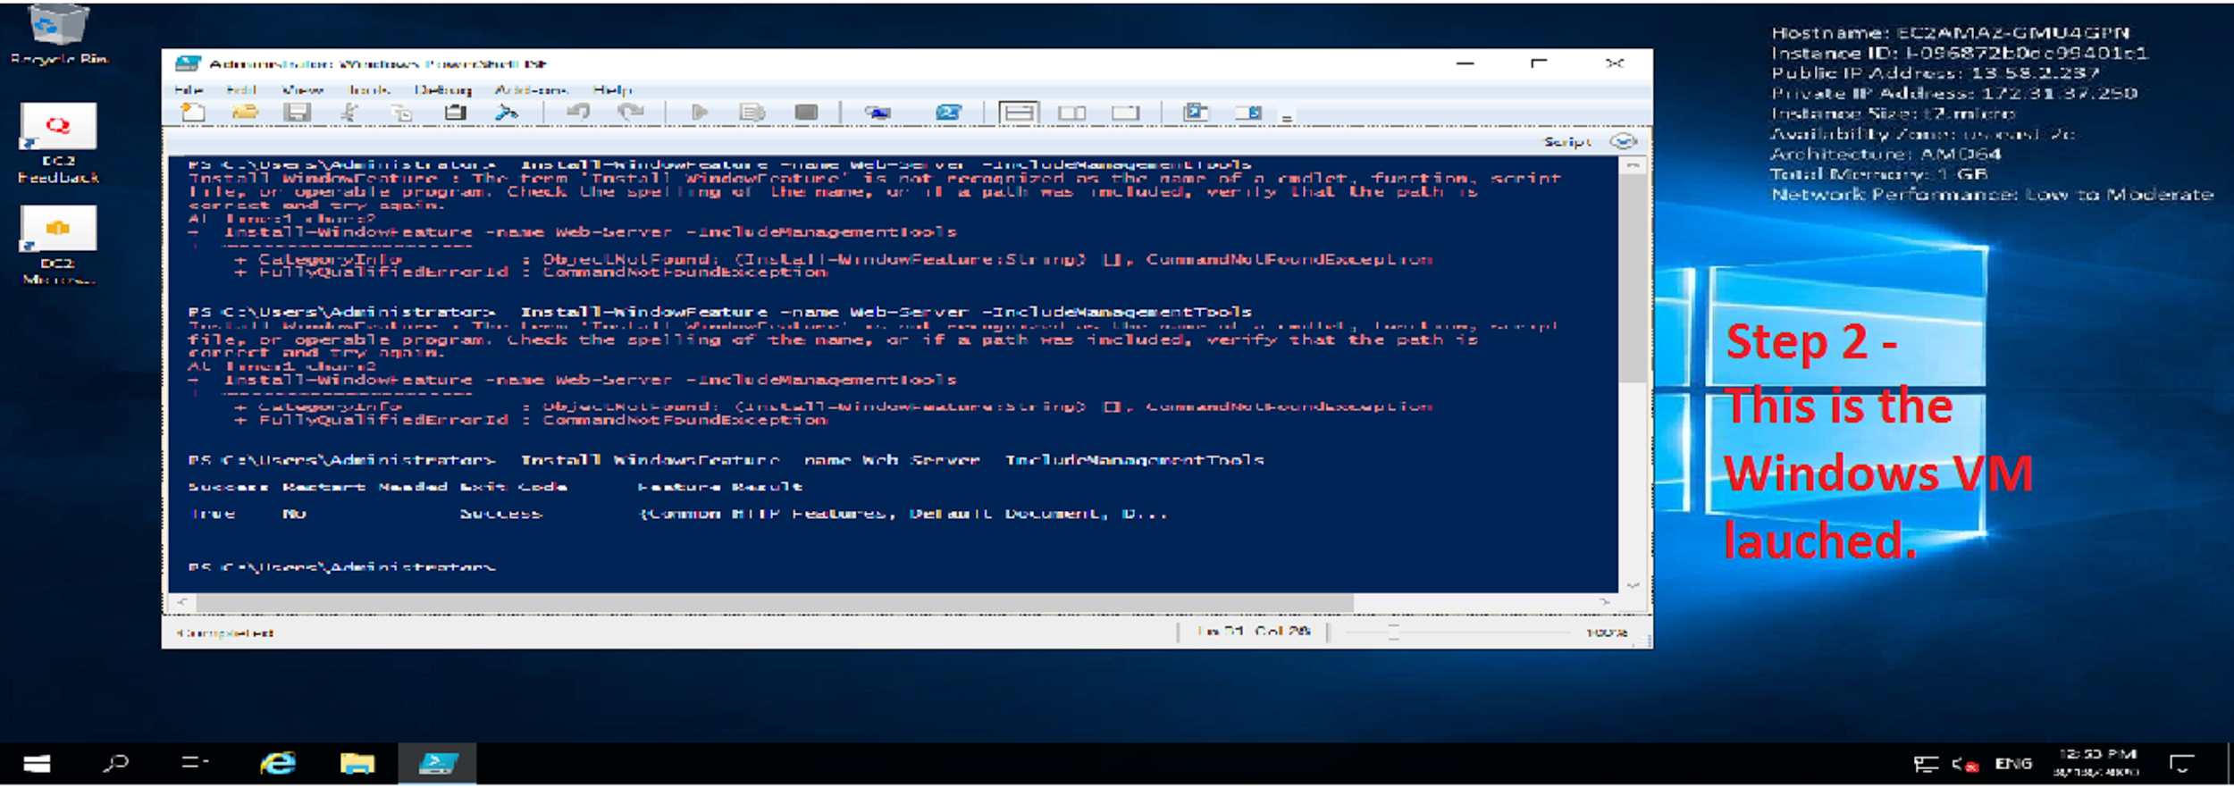

**Step 3 - Acknowledging the IPv4 address by launching it on our browser -**

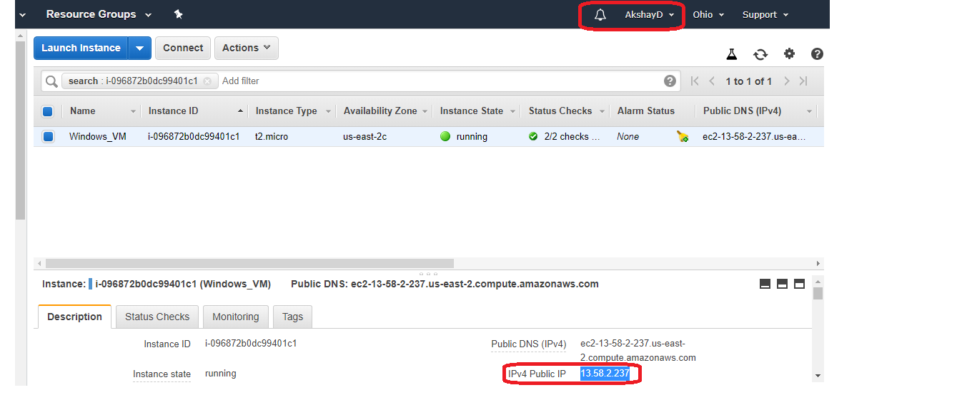

**Step 4 - Launching the respective IP address to access our Windows EC2 Instance -**

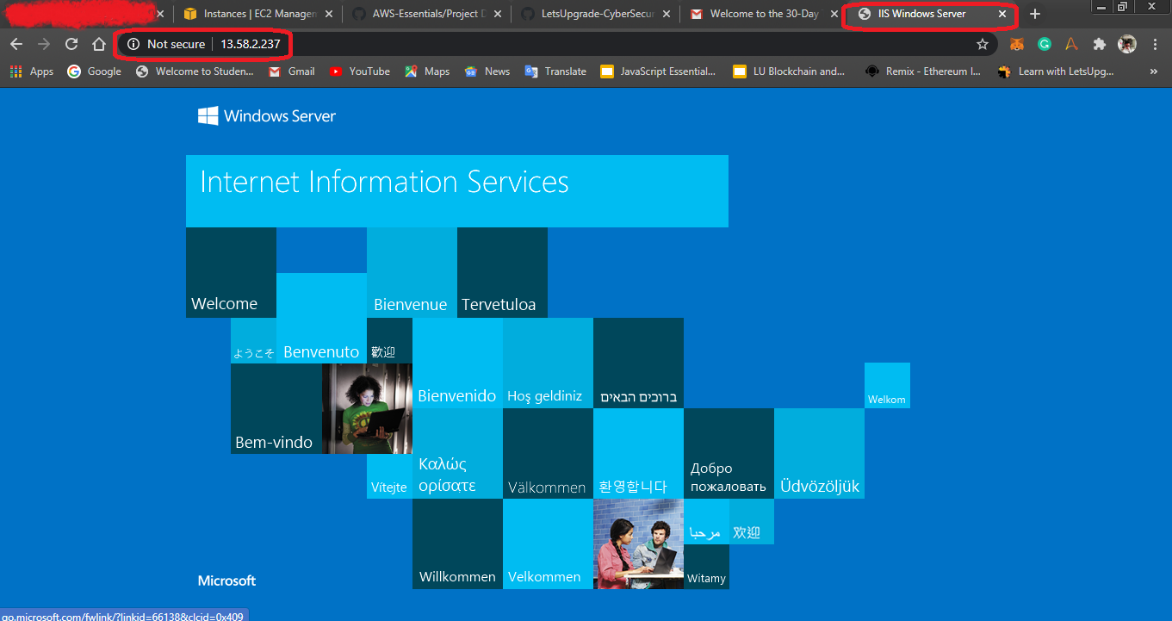

**Project 2 - Launching a Windows Instance using AMI: Ubuntu Server 18.04 LTS(HVM)**

**Step 1 - Choosing the correct AMI Instance for Ubuntu Launch -**

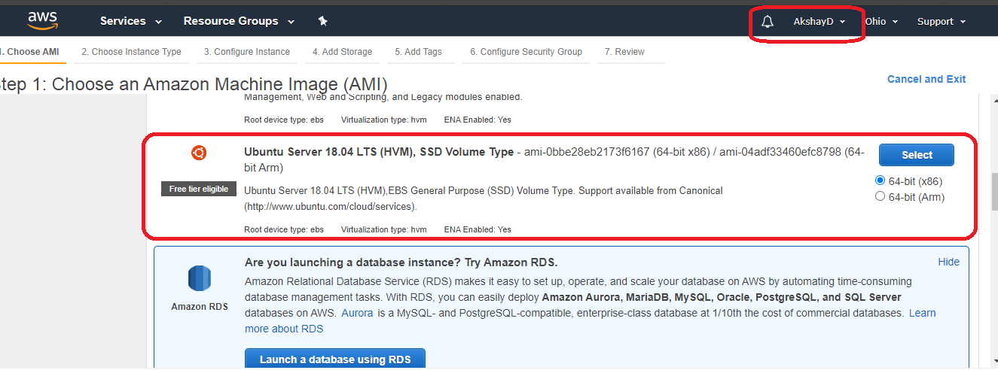

**Step 2 - Complete the Instance’s Launch SetUp process in EC2 -**

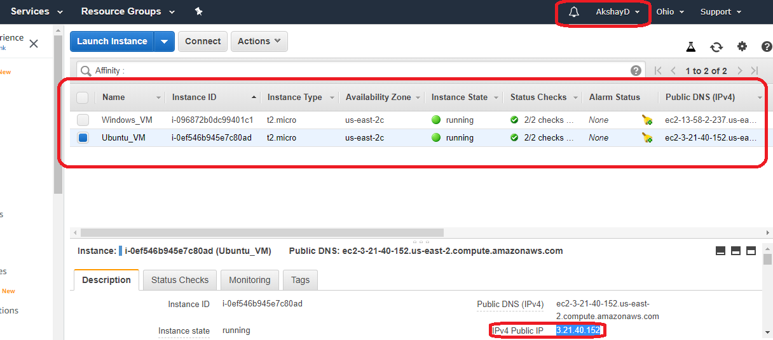

**Step 3 - Launch the Linux/Ubuntu session in MobaXterm using the received IPv4 of our Launched EC2 Ubuntu VM -**

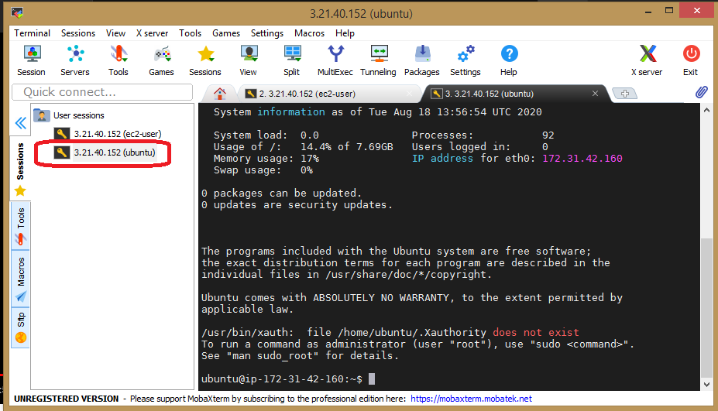

**Step 4 - Install nginx web server using bash(MobaXterm Launcher) -**

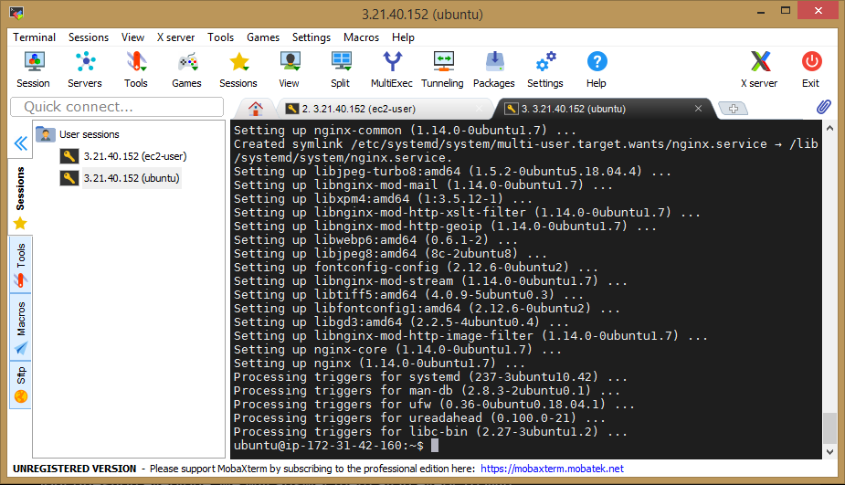

**Step 5 - Launch the Ubuntu Server -**

